

**North South University**

**EEE 111**

**ANALOG ELECTRONICS**

**PROJECT REPORT**

**SUBMITTED BY:** Team ***REVOLUTION***



Section: 11

**SUBMITTED TO:**

Course Instructor’s Name: NEETHILA NABANITA PODDAR

Course Instructor’s Initial: NNP

**Project Name: ALARM SYSTEM USING ARDUINO.**

# Objective:

Currently the use of IOT devices has grown in number and in popularity. People are using IOT

devices in everyday life and adding a touch of automation in their lives. Arduino is also in the family of IOT devices. It’s cheap, easy to program and easy to use. Our main goal is to create an alarm system which is very easy to build and it can also be used in our home, also in our room. So, IOT devices are really interesting and helpful.

# Introduction:

The alarm system is small compared to the ones used in industries and also those which are

used in homes too. The system can detect movement and start the alarm if an intruder comes near. The components needed to build the system are given below:

1. Arduino Uno
2. Ultrasonic Sensor HC-SR04
3. Buzzer
4. Red led
5. Breadboard
6. Jumper Wire

**Total Cost:**

|  |  |
| --- | --- |
| Name of the equipment | Cost (BDT) |
| Arduino Uno | 410 |
| Ultrasonic Sensor HC-SR04 | 300 |
| Buzzer | 15 |
| Red Led | 3 |
| Breadboard | 90 |
| Jumper Wire | 30 |
| **TOTAL** | **848** |

**The Motivation and Goal:**

The number of crimes in our country are increasing day by day. So, indicating the criminals is an important thing. If we become alert then we will be possibly able to stop the crime.

There are many blind people in the world. If they find something that gives them indication while walking it will be very useful for them.

So, we find our motivation to build our project from these two facts.

Our goal is to make people alert whenever any intruder comes in their area and another goal is to help the blind people so that they can have a proper knowledge about things

coming in their way.

# Procedure:

Firstly the Ultrasonic sensor and buzzer is placed on the breadboard. VCC (5v) and GND (ground) is connected from the arduino to the ultrasonic sensor. TRIG is the pin used to send a sonar signal, put this on pin 9 and ECHO is used to read the signal back and therefore calculate the distance which is put on pin 10. In the same way one pin of the buzzer is connected to GND and other is connected to pin 11 so that it can be turned when an intruder crosses a certain distance which is set to the Arduino. Lastly the led is placed directly in the Arduino board in pin 13 and GND, which is shown in the circuit diagram below. Now the necessary code needs to be uploaded to the board in order for it to work properly, which is given below:

# Circuit Diagram: The circuit diagram is given below:

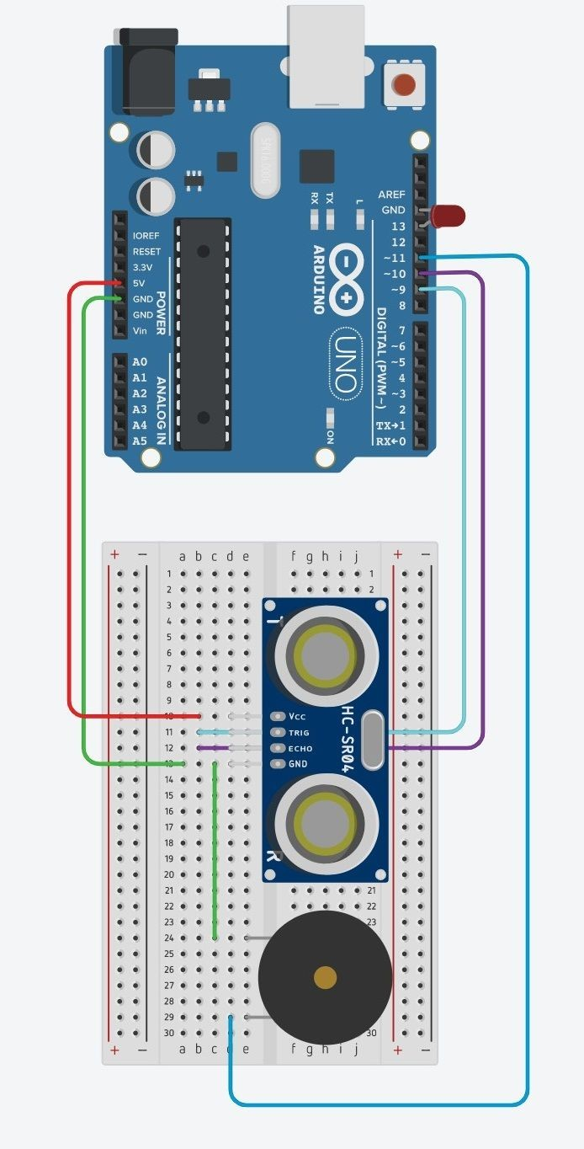

**Code:**

// Pin number const int trig = 9; const int echo = 10; const int buzz = 11; const int led = 13;

long duration; int distance;

int safeDistance;

void setup() { pinMode(trig,OUTPUT); pinMode(echo,INPUT); pinMode(buzz,OUTPUT); pinMode(led,OUTPUT); Serial.begin(9600);

}

void loop() {

//Clears the trig Pin digitalWrite(trig,LOW); delayMicroseconds(2);

//Sets the trigPIn on HIGH state for 10 micro sec digitalWrite(trig,HIGH);

delayMicroseconds(10);

digitalWrite(trig,LOW);

//Reads the echo pins, return the sound wave travel time in microseconds duration = pulseIn(echo,HIGH);

distance = duration*0.034/2;

//Calculating distance safeDistance = distance;

if(safeDistance <= 20){ digitalWrite(buzz,HIGH); digitalWrite(led,HIGH);

}else {

digitalWrite(buzz,LOW); digitalWrite(led,LOW);

}

//Print Distance on the Serial Monitor Serial.print("Distance: "); Serial.println(distance);

}

# Result & Discussion:

After setting up the circuits and uploading the code and power the arduino, which will start detecting. If someone crosses the safety distance it will turn on the alarm and the red led indicating there is an intruder. We can also program the Arduino to do a lot of things, This is a good example that with a few components, we can build a full fledged working system in a low cost and there is an endless possibility to modify and make the system better by

adding few more components.

# Bibliography:

|  |  |
| --- | --- |
| [1] | H. technicians, Director, *Advanced Home Security System using Arduino.* [Film]. Bangladesh: Hungry Technicians, jan 5,2017. Available: https://www.youtube.com/watch?v=b61aPmlg1l8&t=3s |
| [2] | Dejan, "howtomechatronics," howtomechatronics, 24 MARCH 2017. [Online]. Available: https://howtomechatronics.com/projects/arduino-security-alarm-system-project/. [Accessed 25 april 2017]. |
| [3] | V. Shah, "project Hub," project Hub, 24 June 2016. [Online]. Available: https://create.arduino.cc/projecthub/onyx/buzzer-alarm-system-with-help-of-arduino-8be82d. [Accessed 24 march 2016]. |

|  |  |
| --- | --- |
|  |  |
|  |  |